**ajax基础练习**

一、安装wamp

截图：(完成时截图一张即可)

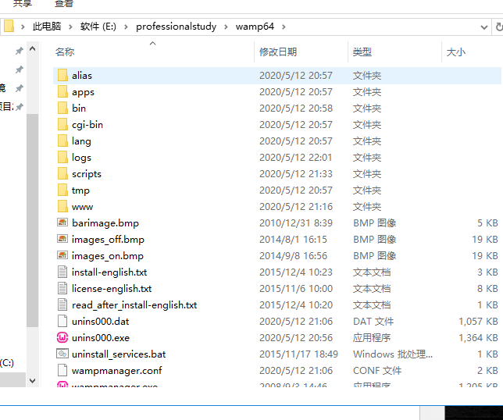

二、设计一个介绍英雄联盟英雄的动态网页

截图：

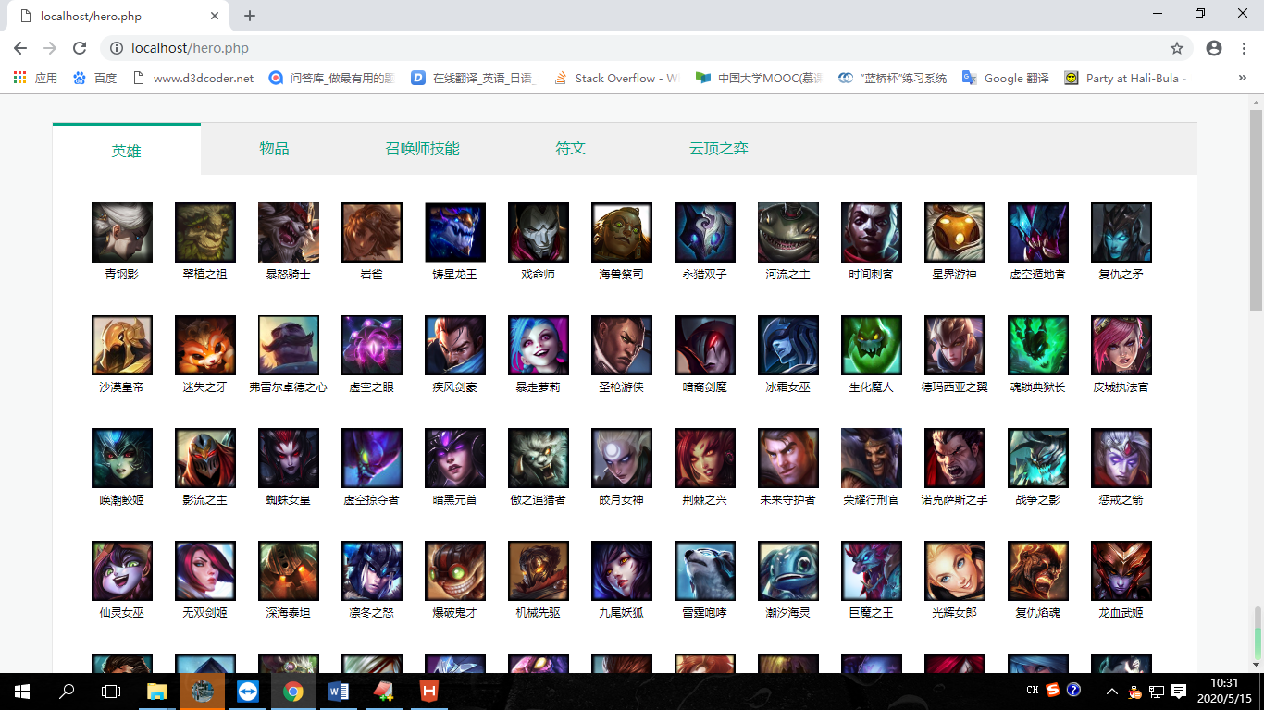

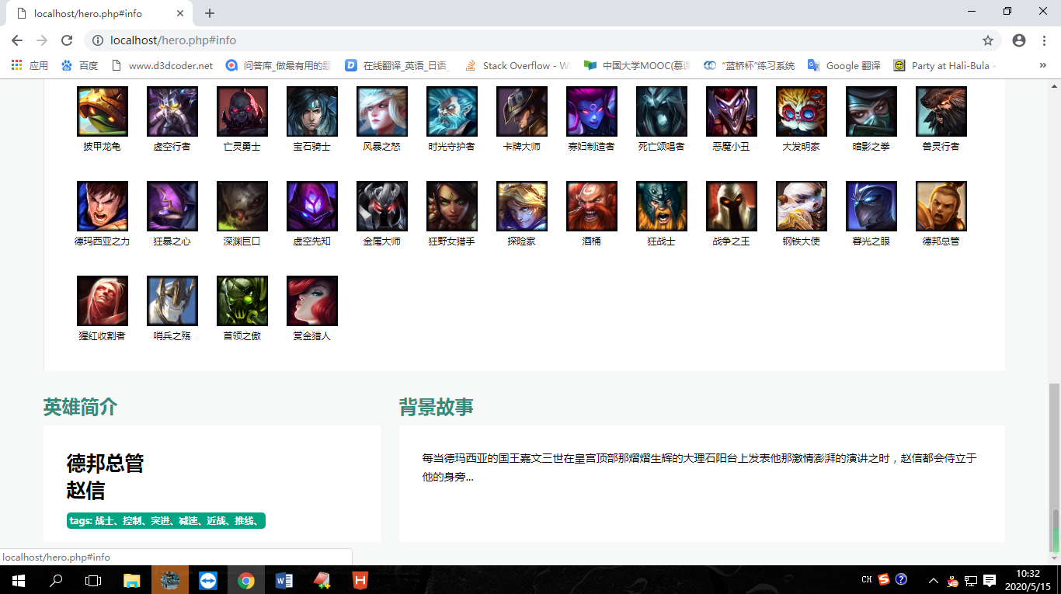

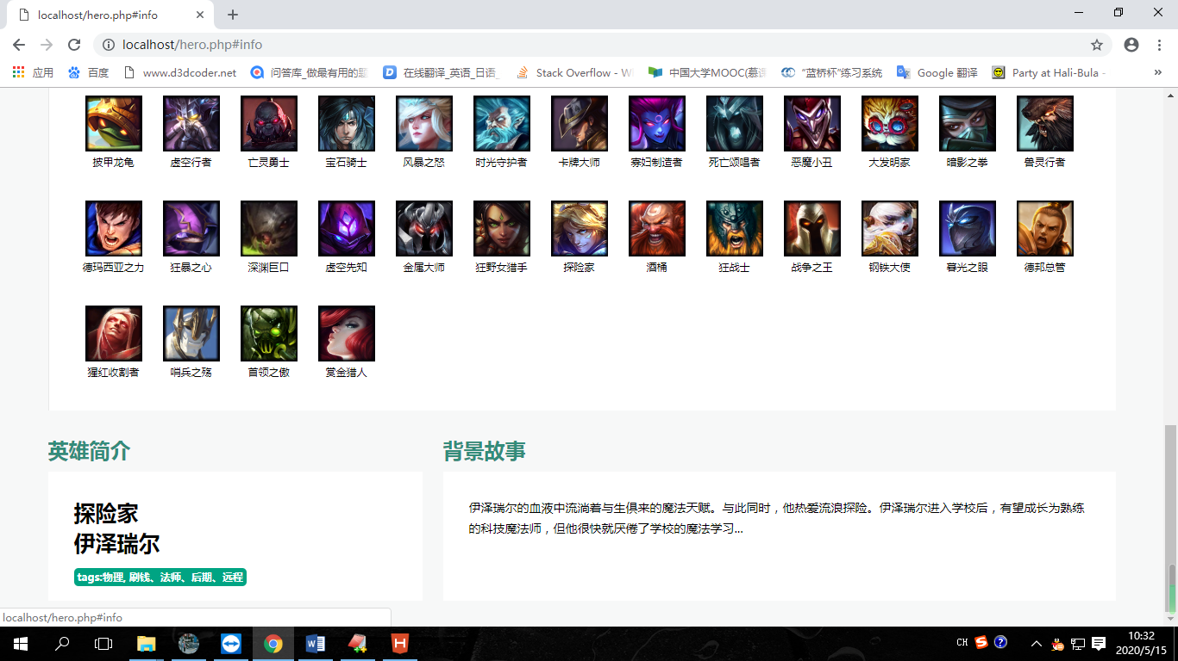

代码：

<!DOCTYPE html>

<html>

<head>

<meta charset="utf-8" />

<title></title>

<style>

*{

margin:0px;

padding: 0px;

}

a{

text-decoration: none;

}

ul{

list-style: none;

}

li{

float:left;

}

body{

background: #F7F8F8;

}

.left{

float:left;

}

.right{

float:right;

}

/*底层最小大小*/

.bottomdiv{

min-width: 1238px;

margin-top: 30px;

margin-bottom: 30px;

}

.widthdiv{

width:1238px;

margin:0 auto;

overflow: hidden;

}

.herodiv{

width: 100%;

border-right: 1px solid #e8e8e8;

border-left: 1px solid #e8e8e8;

border-top: 1px solid #D7D7D7;

box-sizing:content-box;

background: #FFFFFF;

}

.herotitleul{

width: 100%;

background: #F0F0F0;

overflow: hidden;

}

.herotitleul li{

width: 160px;

height: 53px;

text-align: center;

}

.herotitleul li a{

display: inline-block;

line-height: 53px;

color: #00a383;

}

.herotitleul .active{

background: #ffffff;

border-top: 3px solid #00a383;

}

.herotxdiv{

width: 100%;

padding: 30px 37px 0px 30px;;

box-sizing: border-box;

}

.herotxul{

width: 100%;

overflow: hidden;

}

.herotxul li{

width: 90px;

height: 100px;

text-align: center;

margin-bottom: 22px;

cursor: pointer;

}

.herotxul li a img{

width: 66px;

height: 65px;

}

.herotxul li .as{

display: block;

text-align: center;

font-size: 12px;

height: 15px;

color:black;

}

/*英雄介绍*/

.heroinfodiv{

margin-top: 30px;

}

.ptitle{

font-size: 24px;

color: #338c7a;

font-weight: bold;

margin-bottom: 10px;

}

.heroleft{

width: 434px;

}

.heroright{

width:780px;

}

.heroj, .herob{

background: #FFFFFF;

height: 150px;

padding: 30px 30px 30px 30px;

overflow: hidden;

box-sizing: border-box;

}

.spantag{

background: #00A483;

font-size: 12px;

color: white;

display: inline-block;

height: 21px;

line-height: 21px;

text-align: center;

border-radius: 5px;

padding: 0 4px 0 4px;

}

.heroj p{

font-weight: bold;

font-size: 25px;

height: 35px;

line-height: 35px;

}

.herob p{

height: 100%;

word-break:break-all;

font-size: 14px;

line-height: 24px;

overflow: hidden;

}

</style>

<script type="text/javascript" src="js/jquery.js" ></script>

</head>

<body>

<div class="bottomdiv">

<div class="widthdiv">

<div class="herodiv">

<ul class="herotitleul">

<li class="active"><a>英雄</a></li>

<li><a>物品</a></li>

<li><a>召唤师技能</a></li>

<li><a>符文</a></li>

<li><a>云顶之弈</a></li>

</ul>

<div class="herotxdiv">

<ul class="herotxul">

<!--<li>

<img src="images/1371093644361.png">

<a>暗裔剑魔</a>

</li>-->

<?php

include 'heroArr.php';

$dan = "'";

for($i = 0; $i < count($heroArr); $i++)

{

echo '<li class="clickli" onclick="chagnetitle('.$dan.''.$heroArr[$i]['champion_title'].''.$dan.', '.$dan.''.$heroArr[$i]['champion_name'].''.$dan.', '.$dan.''.$heroArr[$i]['champion_info'].''.$dan.', '.$dan.''.$heroArr[$i]['champion_tags'].''.$dan.')">

<a href="#info"><img src="'.$heroArr[$i]['champion_icon'].'"></a>

<a href="#info" class="as">'.$heroArr[$i]['champion_title'].'</a>

</li>';

}

?>

</ul>

</div>

</div>

<div class="heroinfodiv" id="info">

<div class="heroleft left">

<p class="ptitle">英雄简介</p>

<div class="heroj">

<p class="heronickp"></p>

<p class="heronamep"></p>

<p class="herotag"></p>

</div>

</div>

<div class="heroright right">

<p class="ptitle">背景故事</p>

<div class="herob">

<p class="heropb">

</p>

</div>

</div>

</div>

</div>

</div>

<script>

// 需要做的是 点击头像，获取英雄的信息，更新英雄背景故事和简介

function chagnetitle(nick,name,bg,tag){

$('.heronickp').html(nick);

$('.heronamep').html(name);

$('.heropb').html(bg);

$('.herotag').html("<span class='spantag'>"+tag+"</span>");

// 不好分割 太多不同的tag

// var tag = tag.substring(tag.indexOf(":")+1, tag.length);

// var tags = tag.split(", ");

// var tagstr;

// for(var i = 0; i < tags.length; i++){

// tagstr += "<span class='spantag'>";

// tagstr += tags[i];

// tagstr += "</span>";

// }

}

</script>

</body>

</html>